- Download and install the RTD Flasher Software (for Windows PC only – does not work on Mac) - https://files.hptuners.com/rtd%20flasher/rtd%20flasher.msi

- Open the software

- Go connect the RTD to your OBD-II port on the vehicle – Turn the ON/ACCESSORY POSITION - DO NOT START THE ENGINE!

- Connect the USB cable to the RTD and to your PC Laptop

- Ensure you have an internet connection or else the RTD won’t be able to sync to HPT’s servers

- Go to Help > Resync Interface

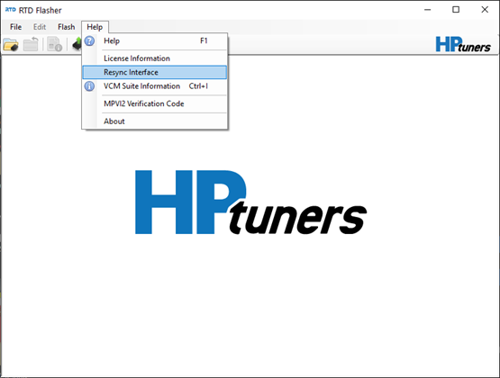

- It will perform a sync and possibly update firmware on the RTD device

- Next go to the VCM Suite Info button and click Gather VCM Suite LOG RED Circled button). It may perform an update here also. Turn the ON/ACCESSORY POSITION - DO NOT START THE ENGINE!

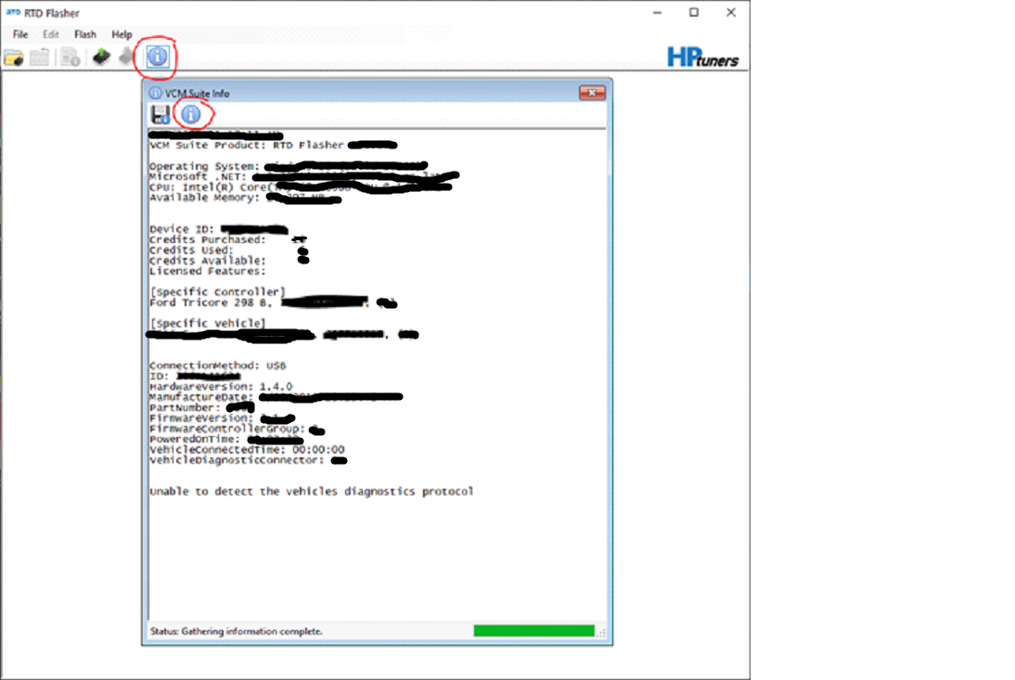

- Click the "Save Information" icon and save the VCM Suite Info Log file to your computer.
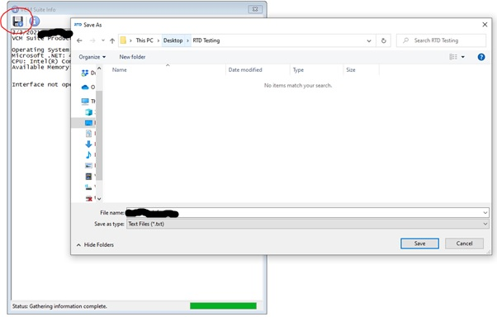
- Next we need to Read abd save the "stock file" off the PCM. Go to Read Vehicle. Turn the ON/ACCESSORY POSITION - DO NOT START THE ENGINE!
It is Strongly recommended that you have a battery charger connected to the car to have a stable Voltage of 12V
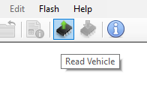
- Follow the on-screen prompts for Reading and Saving the Stock File to your computer
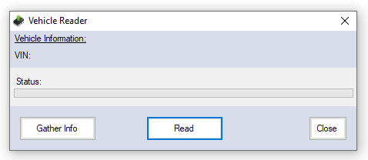
- Now SAVE tune file to your PC and Email Both the Tune File & Info Log to us, it is recommended that you reply to your original email from when you purchased It.
We will also need the car details, Mods List,Rego Number.We will build a tune and email it back to you/

- Next, we can open the tune file for flashing the tune back into the car. Go to File > Open

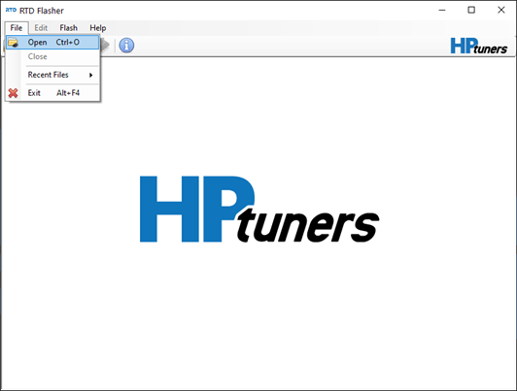

- Find and select the .RTD tune file we sent to you.
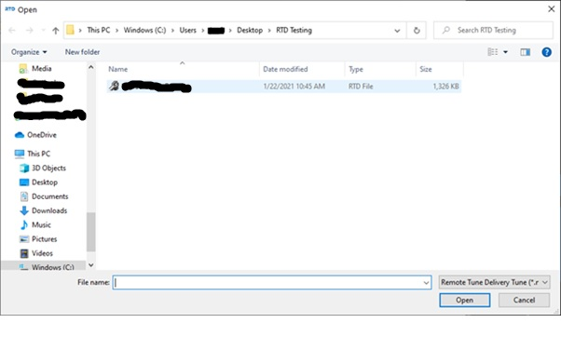

- Next, go to Write Vehicle and follow the onscreen prompts to flash the tune to the PCM. You will have to cycle the ignition (key on engine off) –

DO NOT START THE ENGINE BEFORE OR DURING A WRITE FLASH. DO NOT TOUCH THE IGNITION UNTIL FINISHED – YOU CAN BRICK THE PCM IF YOU DO NOT FOLLOW THE PROCEDURE.
It is Strongly recommended that you have a battery charger connected to the car to have a stable Voltage of 12V

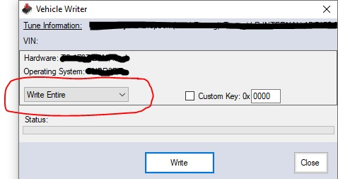
- Once the Flash procedure is complete, it will prompt you to cycle the Key. We usually wait 15 seconds before cycling the key back on. After this, the vehicle is ready to be driven.

